**Exp No: 2** **Date:** 05/09/2020

16-bit Arithmetic Operations **Name:** Swetha Saseendran

**Register Number:** 185001183

Aim:

To write and execute 8086 programs for arithmetic operations of 16 bit numbers like addition, subtraction, multiplication and division.

## Procedure for executing MASM:

1. Open Dosbox and mount the
2. masm folder to the required drive using the command -

(“mount drive-name location-of-masm-file”)

1. Go to the mounted drive (“Drive-name:”)
2. Save the 8086 program with extension .asm in the same folder using command “edit” in Dosbox or use your desired editor and write your program and save in the same location where the masm file is located with extension asm.
3. Assemble it using the command (“masm filename.asm”)
4. Link the file using the command (“link filename.obj” )
5. Debug the file to execute and analyse the memory contents,
6. (“debug filename.exe”).
7. Now use command “u” to display the unassembled code.
8. Use command (“d segment:offset”) to see the content of memory locations starting from segment:offset address
9. Execute using the command “g” and check the outputs by repeating the previous step.
10. Use command (“e segment:offset”) to edit the variables.
11. Command “q” to exit from debug and command “exit” from command prompt to close dosbox.

# Programs:

### (i) 16-bit Addition:

## Algorithm:

* Move the data segment to the AX register and then move it to the DS register.
* Move the first operand to AX register.
* Move the second operand to the BX register
* Initially set the CX register to 0000h.
* Then add using ADD AX, BX.
* Using JNC instruction check for carry and if there is no carry, no need to increment CX.
* Else, increment CX by 1.
* The result and carry stored in AX and CX should be moved to RESULT and CARRY respectively.
* Terminate the program

|  |  |
| --- | --- |
| **Program** | **Comments** |
| assume cs:code, ds:data | Using assume directive to declare data and code segment |
| **data segment**  opr1 dw 1234h  opr2 dw 5140h  result dw 0000h  carry db 00h  **data ends** | Declaring and initialising variables in data segment |
| **code segment**  org 0100h | Set location for code segment at 0100h |
| **start:** mov ax,data | Transferring address of data segment to ds |
| mov ds,ax |  |
| mov ax,opr1 | Value of opr1 is loaded to ax |
| mov bx,opr2 | Value of opr2 is loaded to bx |
| mov ch,0000h | Initializing the value of ch |
| add ax,bx | ah=ax+bx |
| jnc here  inc cx | Jump to “here” segment if no carry is generated  cx=cx+1 |
| **here:** mov result,ah | Load register value of ah to result |
| mov carry,ch | Load ch value to carry |
| mov ah,4ch | Moves the hexadecimal value 4c to ah. |
| int 21h | When Software interrupt 21 is called with AH=4C, then current process terminates |
| code ends | Ending the segment with the segment name |
| end start |  |

## Unassembled Code:

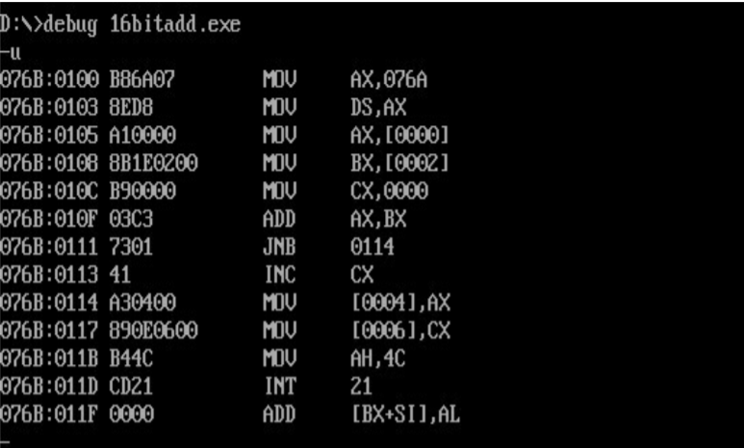

## Snapshot of sample input and output:

**Input:**

opr1=9999

opr2=7777

**Output:**

Result:1110

Carry: 0001

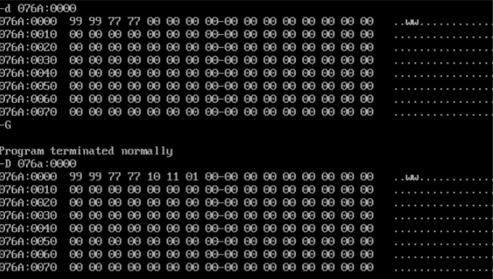

### (ii) 16-bit Subtraction

## Algorithm:

* Initialize the data segment
* Move data segment address to ds
* Load operand-1 to ax and operand-2 to bx
* Load 00h to ch register
* Subtract ax and bx
* If ax is greater than bx, goto here segment else, increment cx by 1 and find the 2’s complement of ah
* In here segment,
* Load ax to result
* Load cx to borrow
* Terminate the program

|  |  |
| --- | --- |
| **Program** | **Comments** |
| assume cs:code, ds:data | Using assume directive to declare data and code segment |
| **data segment**  opr1 dw 11h  opr2 dw 99h  result dw 00H  borrow db 00H  **data ends** | Declaring and initialising variables in data segment |
| **code segment**  org 0100h | Set location for code segment at 0100h |
| **start:** mov ax,data | Transferring address of data segment to ds |
| mov ds,ax |  |
| mov ax,opr1 | Value of opr1 is loaded to ax |
| mov bx,opr2 | Value of opr2 is loaded to bx |
| mov cx,0000h | Initializing the value of cx |
| sub ax,bx | ax=ax-bx |
| jnc here | Jump to “here” segment if ah>bh |
| inc cx | Increments ch by 1 (cx=cx+1) |
| neg ah | 2’s complement of ah |
| **here:** mov result,ax | Load register value of ah to result |
| mov borrow,cx | Load ch value to borrow |
| mov ah,4ch | Moves the hexadecimal value 4c to ah. |
| int 21h | When Software interrupt 21 is called with AH=4C, then current process terminates |
| code ends | Ending the segment with the segment name |

## Unassembled Code:

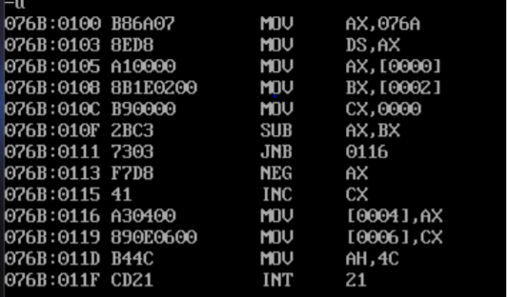

## Snapshot of sample input and output:

**(i) Input:**

opr1=9999

opr2=7777

**Output:**

Result:2222

Carry:0000

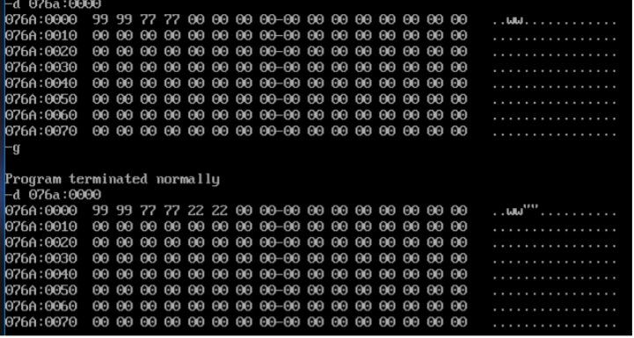

**(ii) Input:**

opr1=1001

opr2=2100

**Output:**

Result: 10FF

Carry: 0001

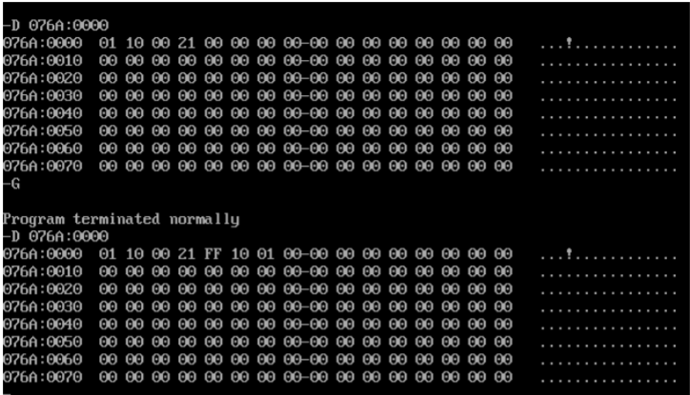

## (iii) 16-bit Multiplication:

## Algorithm:

* Initialize the data segment
* Move data segment address to ds
* Move the first operand to AX register.
* Move the second operand to the BX register.
* Multiply using MUL BX. (Since AX is default operand register for MUL instruction we only need to specify the other operand register.)
* The lower order and higher order result bits stored in AX and DX are now to be transferred to lsb and msb respectively

## Unassembled Code:

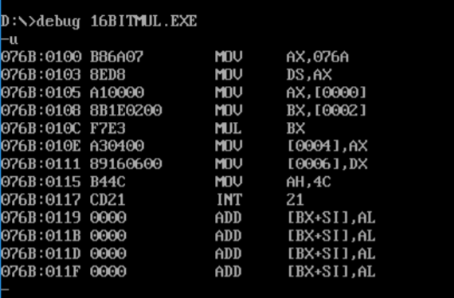

|  |  |
| --- | --- |
| **Program** | **Comments** |
| assume cs:code, ds:data | Using assume directive to declare data and code segment |
| **data segment**  opr1 dw 1111h  opr2 dw 9999h  lsb dw 0000H  msb dw 0000H  **data ends** | Declaring and initialising variables in data segment |
| **code segment**  org 0100h | Set location for code segment at 0100h |
| **start:** mov ax,data | Transferring address of data segment to ds |
| mov ds,ax |  |
| mov al,opr1 | Value of opr1 is loaded to al |
| mov bl,opr2 | Value of opr2 is loaded to bl |
| mul bx | dx ax=ax x bx |
| mov result1,ax  mov result2,dx | Load register value of ax to result1  Load register value of dx to result2 |
| mov ah,4ch | Moves the hexadecimal value 4c to ah. |
| int 21h | When Software interrupt 21 is called with AH=4C, then current process terminates |
| code ends | Ending the segment with the segment name |
|  |  |

## Snapshot of sample input and output:

Input :

opr1=9999

opr2=7777

Output:

Result: 47AD851F

[Result2: 47AD Result1: 851F]

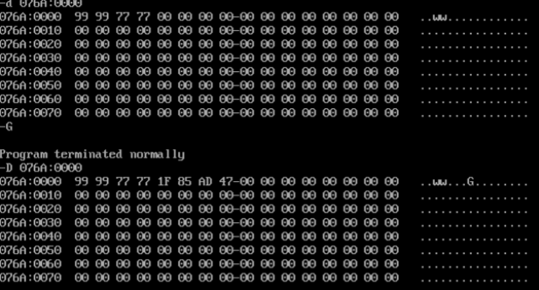

### (iv) 16-bit division:

## Algorithm:

* Initialize the data segment
* Move data segment address to ds
* Move the data segment to the AX register and then move it to the DS register.
* Now, set DX register to 0000h and move first operand to AX register.(Since we can’t directly divide a 16 bit number by 16 bit number in 8086, we now make our dividend 32 bit by storing 0000h in DX register and the 16-bit operand 1 in AX register).
* Move the second operand to the BX register.
* Now divide using DIV BX. (It will perform DXAX / BX. Because DX is 0000h, what actually happens is the division of a 32 bit number by a 16 bit number.)
* The quotient and remainder stored in AX and DX should be moved to QUOTIENT and REMAINDER respectively.

## Unassembled Code:

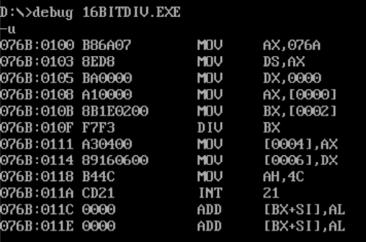

|  |  |
| --- | --- |
| **Program** | **Comments** |
| assume cs:code, ds:data | Using assume directive to declare data and code segment |
| **data segment**  opr1 dw 11h  opr2 dw 99h  quo dw 00h  rem dw 00h  **data ends** | Declaring and initialising variables in data segment |
| **code segment**  org 0100h | Set location for code segment at 0100h |
| **start:** mov ax,data | Transferring address of data segment to ds |
| mov ds,ax |  |
| mov ax,opr1 | Register ah is loaded with 00 |
| mov bl,opr2 | Value of opr1 is loaded to ax |
| div bx | Value of opr2 is loaded to bl |
| mov quo,al | dx ax / bx |
| mov rem,ah | Load register value of al to result |
| mov ah,4ch | Moves the hexadecimal value 4c to ah. |
| int 21h | When Software interrupt 21 is called with AH=4C, then current process terminates |
| code ends | Ending the segment with the segment name |
|  |  |

## Snapshot of sample input and output:

**Input:**

opr1=9999

opr2=7777

**Output:**

Quotient:0001

Remainder:2222

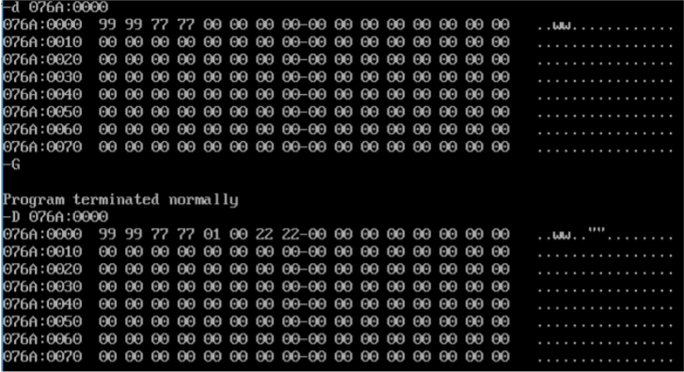

## Result:

The assembly level program to perform basic arithmetic operation of two 16-bit numbers using an 8086 microprocessor has been implemented.